COMP422 Mini-Project
Group Project
*
Development of a Content-Based Logo Image Search Engine

Group Member:
CHENG Wai Hung (02703340t)
TAM Koon Wing (02706110t)

Table of Content:

- Objectives
- Development Tools
- Programming Method
- Program Layout

I ) Objectives
To Develop a simple content-based image retrieval system which should be able to create an index file of color histogram vectors for a given collection of images and to carry out query by only input an image with expectation of ‘n’ best number of matching images return chosen by users.

II) Development Tools
Programming language : Java
Data storage : Text file
Platform : Windows OS
Algorithm : Color Histogram

III ) Programming Method

A) To create/build index file of color histogram vectors for a given collection of images :-

Steps
- To collect all of the given images provided.
- Get the image pixel length and width for each one.
- Use Java build function ‘ColorModel.getRGBdefault’ to get the correspondence color information from each image.
- Use 64 color bins to store each image color histogram vectors.
- Do the normalization for each one.
- Store/Write the image into file
- Repeat step 1 until all collected images were done.

B) To carry out query by input image with expected ‘n’ best returns of matching images from the archive that chosen by user :-

Steps
- Get input image from user with respected ‘n’ best returns number of matching images.
- Get the image pixel length and width.
- Use function ‘ColorModel.getRGBdefault’ to get the correspondence color information.
- Use 64 color bins to store the image color histogram vectors.
- Do the normalization.
- Get the stored images from file and do the matching by calculated the different values of the input image and the one get from archive. Similarity function was used.
- The different values of each images from archive is stored into array.
- Sort the array and to find out the best ‘n’ return number of matching images which have the smallest number compared with the others and show the images in ascending order.

IV ) Program Layout

- Issue command “java Mainframe” on the Command Prompt to display mainframe of Image Search Engine.
- Click “Build Index” button to display secondframe of build index.
- Enter the total no. of index you wanted to build and click “Start” button to build image database.
- You also click “Image Search” button to display thirdframe of search image from mainframe.
- Firstly, you must enter ‘n’ best number of matching images return, then select your query image by click “browser” button. Finally, you may click “Search” button to found n closest images.

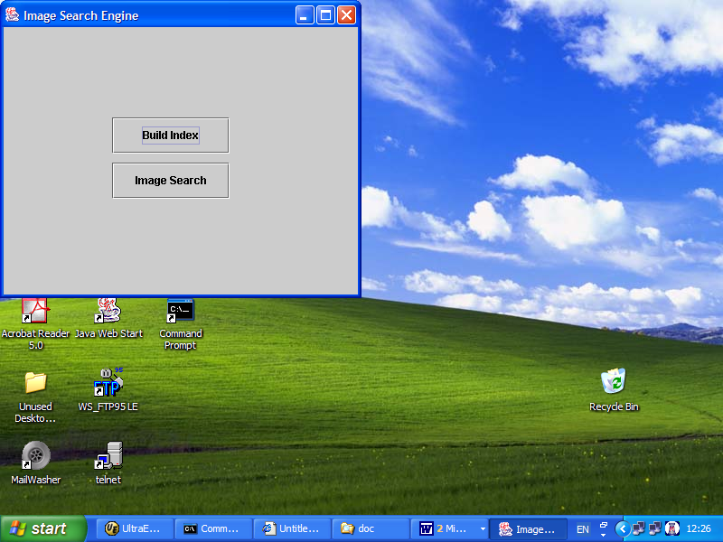

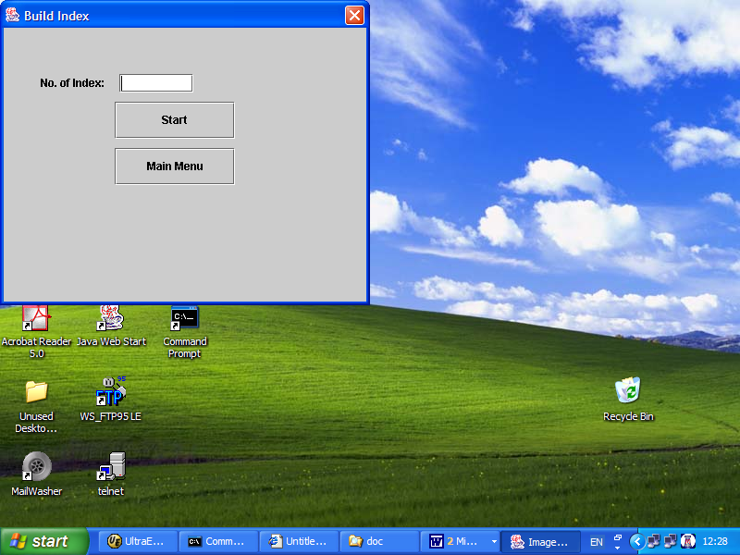

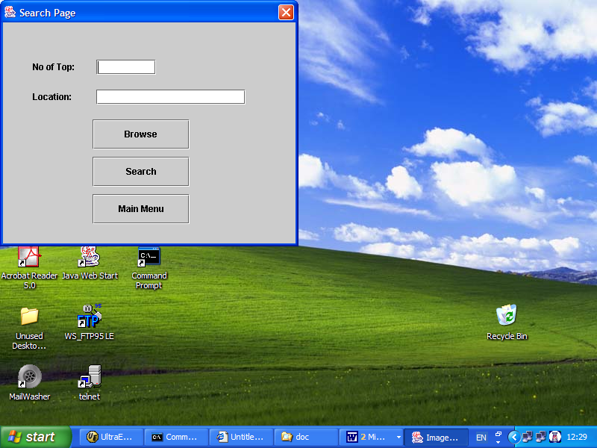

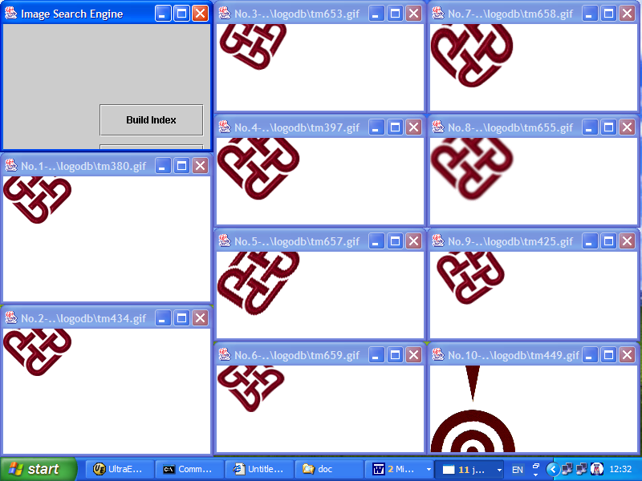

* * End of Report * *

